

COAL (LAB)
Week 7

Name of Students | Sap ID | Program | Email Address
Laraib salam | 61996 | BSCS 3 | 61996@students.riphah.edu.pk

Submitted to
Mam rehana

Tasks 1:
- Write a program in assembly language to print your CV or Biodata.

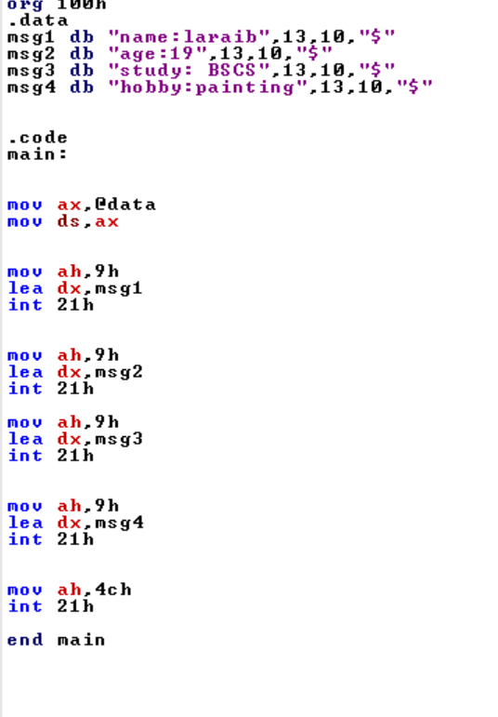

Output

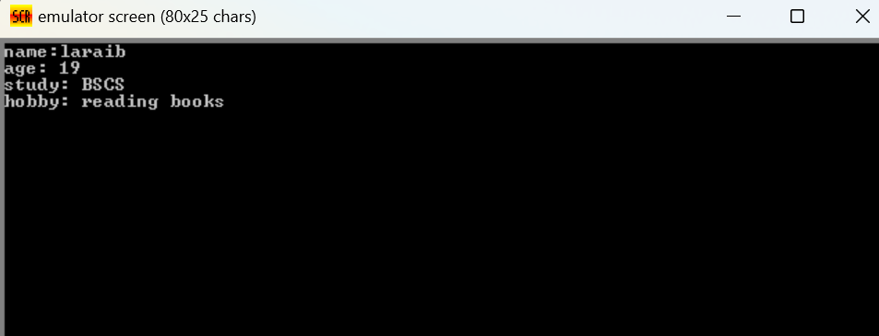

Tasks :2
Write a program that input a character from user and print that again on screen in the given format. The user entered x character.
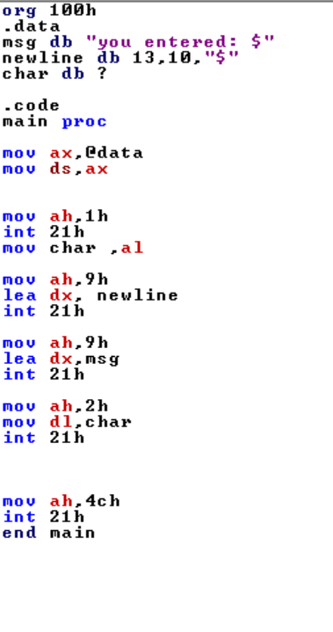

output

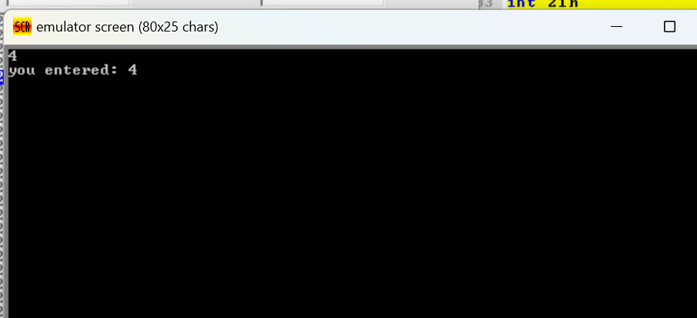

Tasks 3
Write a program that input a character from user is in lowercase, the program will convert it to uppercase and will display it on console after conversion. Show messages stored in variable strings to the user.

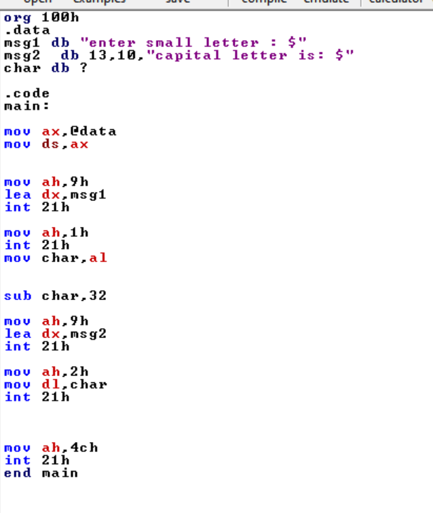

Output

